**Individual Assignment Submission (Bearcat Event Manager)**

**Sai Achyuth Konda – Team 1**

Project Setup and Technical Stack:

* Frontend: React.js
* Backend: Firebase Firestore (NoSQL database) and Firebase Authentication
* Project Management: Jira Dashboard for task tracking and progress monitoring
* Version Control: GitHub for code commits and version management

**List the tasks that you were assigned for the week?**

1. Jira Dashboard Setup and Sprint Planning.
2. Firebase Project Setup for Authentication and Firestore Database.
3. Initial React Project Setup and Folder Structure Definition.
4. User Authentication (Firebase Integration).
5. Event Creation and Management Features Development.

**For each task, link the commit or commits that completes the task?**

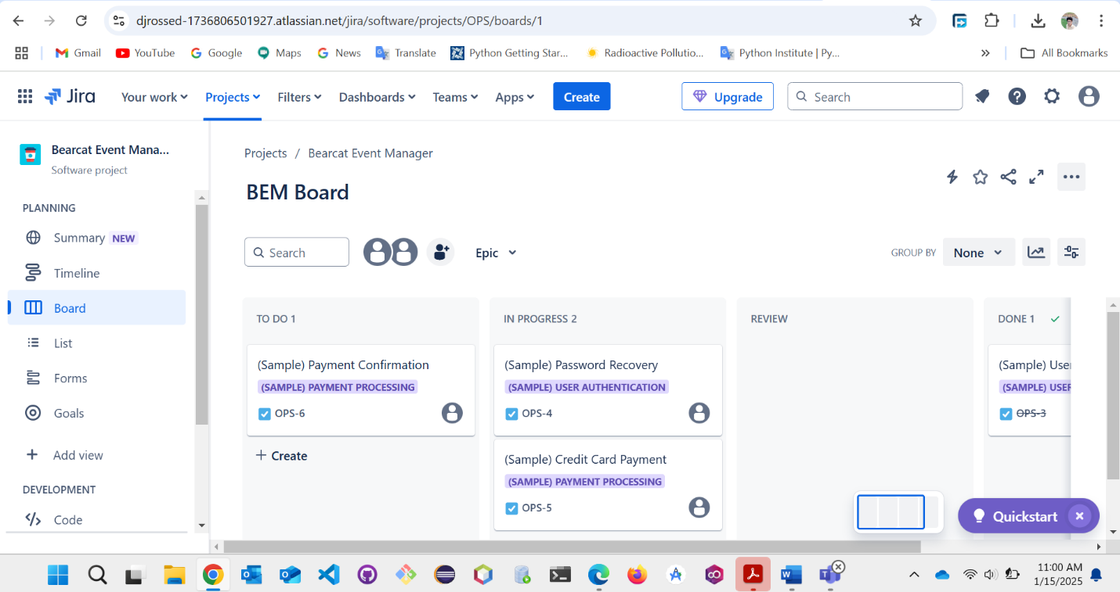

**Explain how you can verify that the tasks you were assigned were completed?**

1.Jira Dashboard Setup and Sprint Planning:

* we will create a Jira board with Epics, Stories, and Tasks for event management features.
* we will Configure sprints with a two-week timeline for initial project phases.
* priorities based on project milestones.

Verification: Task tracking in Jira reflects progress and task completion with assignees and due dates.

1. Firebase Project Setup:

* we will Create a Firebase project and linked it to the React app.
* we will Enable Firebase Authentication (Email/Password sign-in).
* we will Configure Firestore Database for event and user data storage.
* we will Setup Environment Variables (.env) for secure Firebase credentials.

Verification: connect a Firebase with a test console.log check and Firestore write operation.

1. User Authentication with Firebase Integration:

* we will Integrate Firebase SDK and AuthContext using React Context API.
* we will Implement signInWithEmailAndPassword() and createUserWithEmailAndPassword() for login and registration.
* we will Implement secure role-based routing for User and Admin dashboards using React Router.

Verification: we will Test sign-up, sign-in, and sign-out processes with both correct and incorrect credentials, ensuring proper error messages and access control.

**Task must match the requirement of designed software documents. (Software environment setup usually not considered as part of this point, but no deduction applied)?**

How Tasks Match Project Requirements:

* Jira Setup: Matches the requirement for structured project management.
* Firebase Setup: Matches the need for a secure database and user authentication system.
* React Project Structure: Matches development best practices for scalability and maintainability.
* User Authentication: Matches the requirement for a secure login system.
* Event Management Features: Matches the requirements for event creation, management, and search capabilities.